Key vocabulary
nutrition | Food necessary for health and growth.
nutrients | Useful substances that help animals and plants grow.
carbohydrates | These are the foods that give us energy. They are found in sugary and starchy foods.  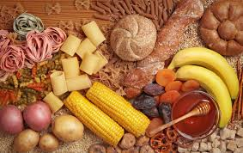
proteins | These are important so the body can grow, repair and build muscle.  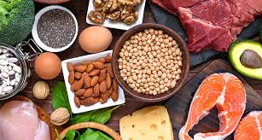
vitamins and minerals | Substances found in foods which keep us healthy. These are found in fruit and vegetables.  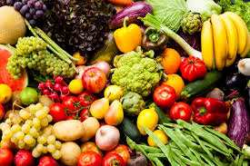
fibre | This lets food pass quickly through your body. It helps keep your digestive system in good working order.
skeleton | This supports and protects the body, allowing it to move.
bones | The hard parts inside your body which form your skeleton.
muscles | These are attached to bones and help us move.
joints | The place where 2 bones meet.

Animals including humans – Year 3
Significant scientist
Wilhelm Conrad Rontgen  (1845-1923)  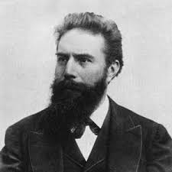 | Wilhelm Rontgen was a German physicist who discovered X-rays in 1895.  He was awarded many honours and won the Nobel Prize for physics in 1901.

Animals need to eat food to get the nutrients they need.

What type of foods should we eat to stay healthy?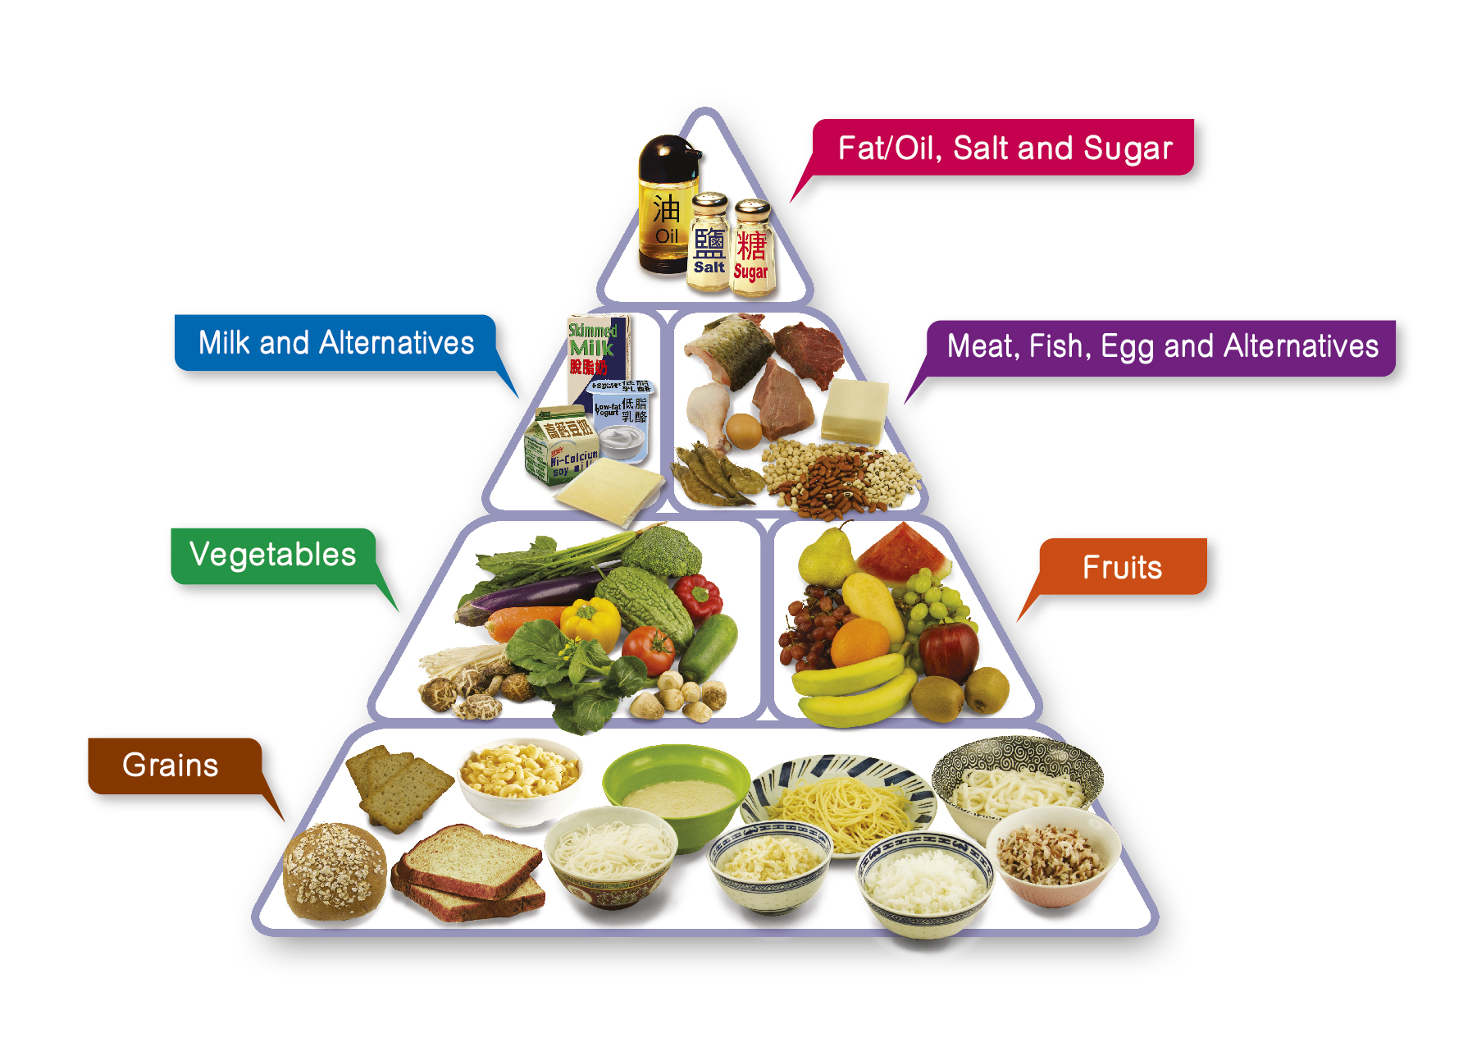
One piece of food can provide a range of nutrients.

The skull protects our brain.

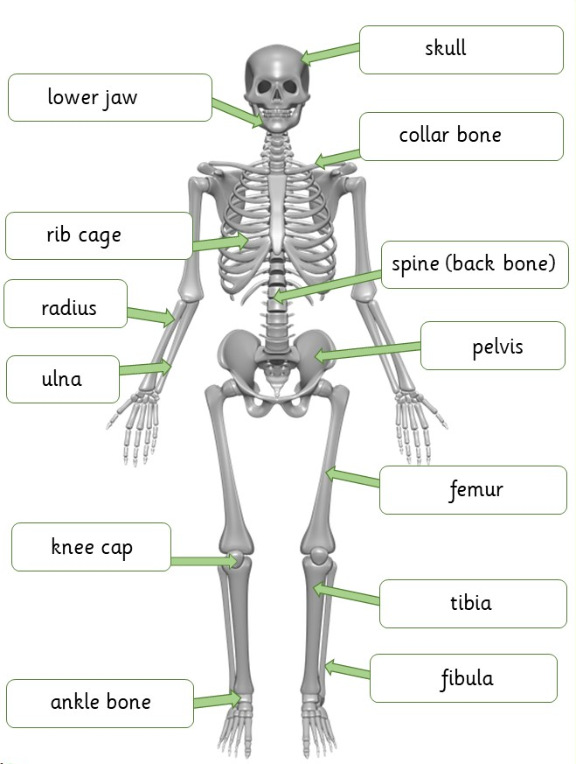
The bones in our legs support us and help us stand.
The bones and muscles in our legs help us move.

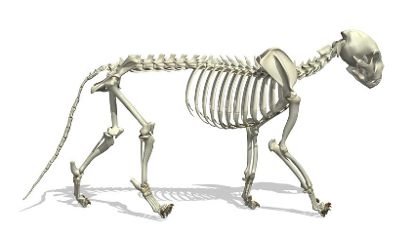
A cat skeleton

