Key vocabulary
force | A force is a push or a pull. Forces make objects start moving, stop moving, speed up, slow down or change direction.
gravity | A force which pulls things down towards the centre of the Earth.
forcemeter | Piece of equipment used to measure the size of a force.
Newton (N) | The unit for measuring force.
air resistance | The force that slows down objects that move through air.
water resistance | A force that slows down objects moving through water.
friction | When one surface moves against another, the rubbing force that tries to stop them is called friction. It gives us grip.
mechanisms | A device that allows a small force to be increased to a larger force.
simple machines | Levers, pulleys and gears are all types of simple machines.
Dolphins have a streamlined shape.
Real-life examples of forces in action

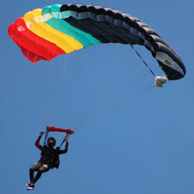  A skydiver falls fast until they open their parachute. |  | 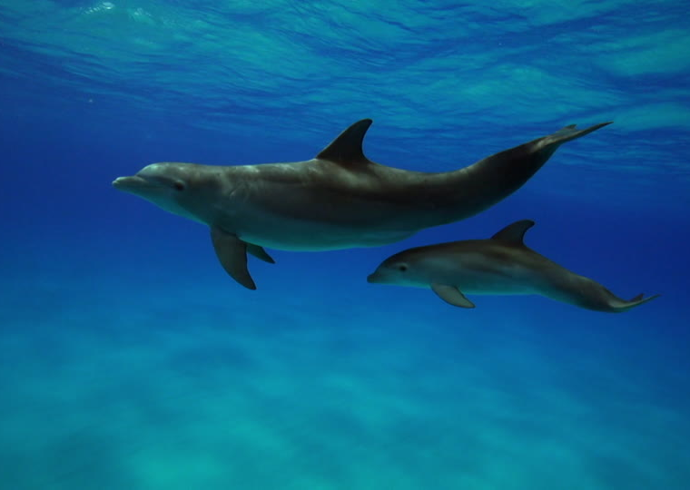
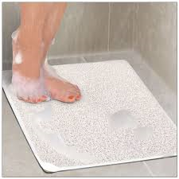
A non-slip mat uses friction.
Forces – Year 5
Significant scientists
Traditional
Galileo Galilei  (1564-1642)  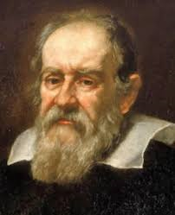 | He was an Italian scientist.  He discovered that if two objects of similar shape and size are dropped, they will fall at the same rate.
Sir Isaac Newton  (1642-1726)  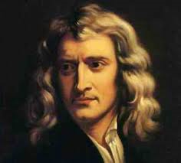 | He was an English scientist and mathematician.  He ‘discovered’ the concept of gravity when sitting under a tree and an apple fell to the ground near him.
Contemporary
Emma England - Aeronautical engineer
Emma works as part of a team designing the wings of aircrafts.
Seeds fall to the ground because of gravity.

Simple machines
These are used to make tasks easier. This means you need to use less force.
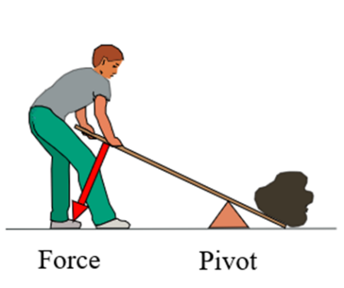
A lever tilts on a pivot which is nearer to the end of the pivot with a heavy load.
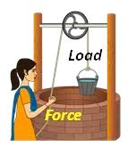 | 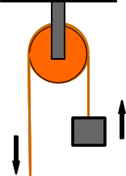
Pulleys have a rope or cable which goes over a wheel. This is pulled to lift, lower or move heavy objects.
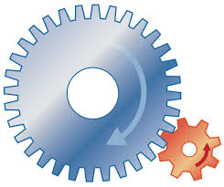
Gears are toothed wheels which lock together and turn each other to form simple machines.

