The four seasons
Autumn
Leaves change colour and fall. Harvest time is in autumn.
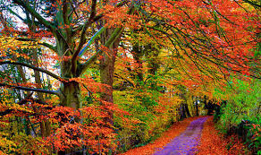
Winter
The coldest time of the year. Some animals hibernate.
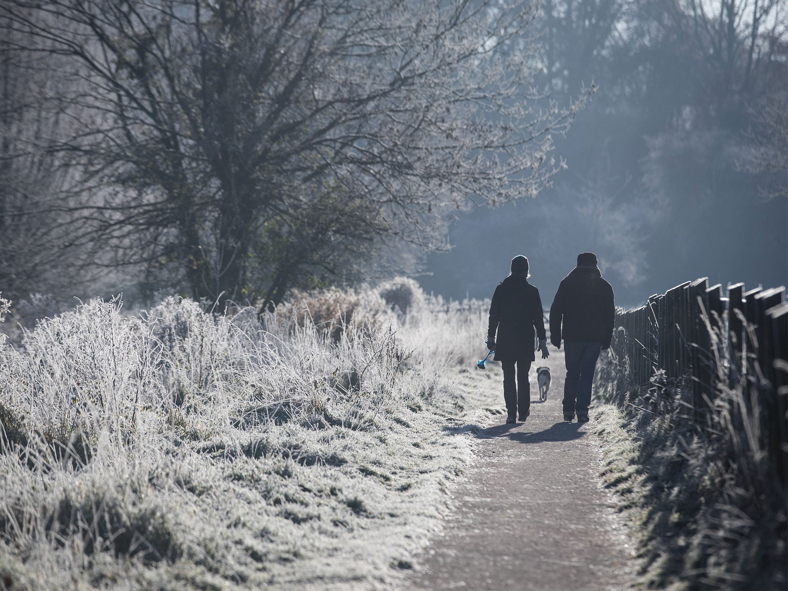
Spring
Flowers begin to grow. Some baby animals are born.
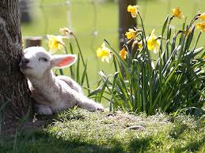
Summer
The hottest time of the year. Flowers and trees are in full bloom.
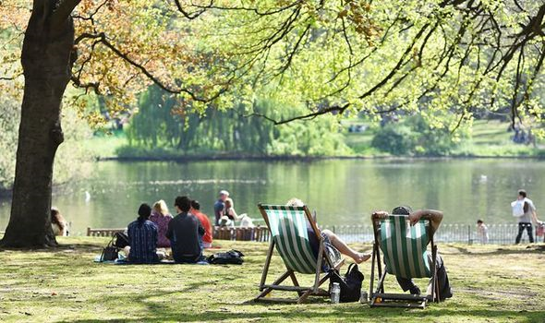

Seasonal changes
– Year 1
Key vocabulary
Season | Seasons are periods of similar weather. We have 4 seasons.
Autumn | Autumn takes place in:  - September  - October  - November
Winter | Winter takes place in:  - December  - January  - February
Spring | Spring takes place in:  - March  - April  - May
Summer | Summer takes place in:  - June  - July  - August
Weather | This is how sunny, rainy, windy, snowy etc that it is. It changes with the seasons.
sunrise | The time in the morning when the sun first appears in the sky.
sunset | The time in the evening when the sun disappears out of sight in the sky.

Day length
The longest day of the year in the UK is in  mid-summer.  This falls on June 21st. | Summer solstice  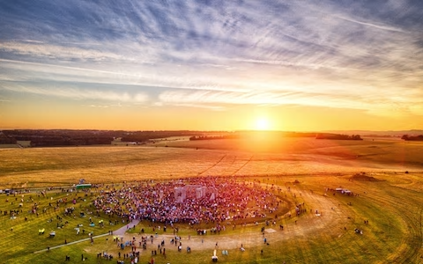
The shortest day of the year in the UK is in  mid-winter.  This falls on December 21st. | Winter solstice  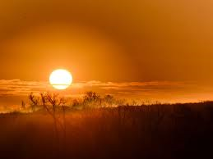

Weather symbols
We can use these to record what the weather is like where we live.

