Key vocabulary
rock | A naturally occurring material made of minerals. They can be different sizes:  - stones  - pebbles  - boulders
fossil | The bones or other remains of living things are sometimes preserved in rocks as fossils.
soil | Ground up rock mixed with plant and animal remains.

Soils
The property of soils is affected by the:
- type of rock
- size of rock pieces
- amount of organic matter in it.

Peat  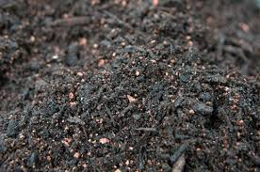 | - water-logged  - contains partially decomposed plant material  - soft and easily compressed
Sandy soil  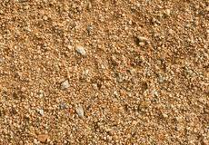 | - light and dry  - lots of air gaps so water drains through quickly
Chalky soil  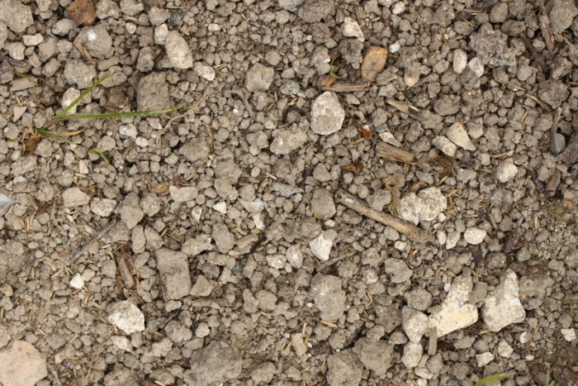 | - stony and water drains through quickly  - found in areas with lots of chalk
Clay soil  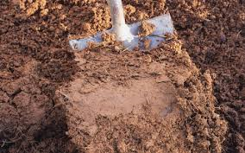 | - very sticky when wet  - a heavy soil  - water does not drain through it quickly
Rocks – Year 3
Significant scientists
Mary Anning  (1799-1847) | Mary Anning was an English palaeontlogist and fossil collecter. She became known around the world for important finds she made in Jurassic fossil beds in Dorset.
Holly Betts
PhD student, University of Bristol
Holly is a palaeobiologist. She is researching whether fossils are best for establishing a timescale for recent and ancient episodes in our evolutionary history.

Fossil formation
Fossils were formed millions of years ago.
1 Plants and animals died and sank to the seabed. | Animal fossil  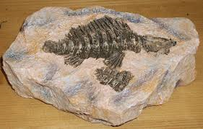  Plant fossil  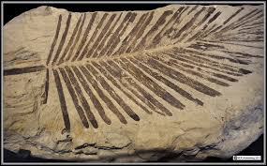
2 The soft parts decayed away leaving the hard parts.
3 The hard parts were covered and squashed by many layers of sand and other materials.
4 The animal/plant matter dissolves and is replaced by minerals, leaving a replica of the original bone called a fossil.
Types of rocks
Sedimentary
sandstone  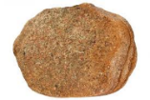 | limestone  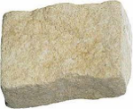
chalk  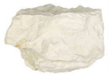 | Chalk is used for drawing because it is crumbly and soft.
Metamorphic
quartzite  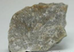 | slate  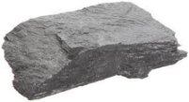
marble | Marble is good for gravestones because it does not rub away.
Igneous
basalt  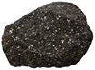 | pumice  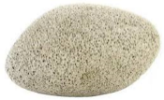
granite  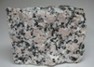 | Granite is good for worktops because it is hard and does not absorb water.

Words to describe the appearance of rocks:
crystals
hard or soft
texture
layers
absorb water or not
grains

