Key vocabulary
puberty | The time when your body begins to develop and change as you become an adult.
sexual reproduction | The process where a living thing creates another organism like itself. In humans, a sperm cell from a male fertilises an egg from a female to produce a baby.
menstruation  (period) | When a woman has a period, she loses a small amount of blood each month.
sperm | Single cells produced by male animals.
egg | A cell that is produced in the body of female animals.
foetus | An animal or human being in its later stages of development before it is born.
gestation | The length of time a mammal carries her offspring inside her body before giving birth.
life expectancy | The length of time that an animal is normally likely to live.
The gestation period of different animals. Larger animals usually have longer gestation than smaller animals.
Animals including humans – Year 5
This topic should be taught alongside PSHE with careful consideration of the school’s Sex and Relationship Education Policy.
Significant scientist
Sarah Fowler  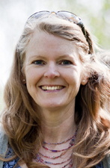 | Sarah Fowler (OBE) is a marine biologist. She is the principal scientist of the Save Our Seas Foundation.  Her research has identified the global threat to sharks and she shares strategies of how we can protect them.

Puberty
- Usually begins between the ages of 8-14 and the process can take up to 4 years.
- During puberty the bodies of boys and girls begin to change physically.
- Boys and girls can experience some mood changes during puberty.
Changes for girls | - hair starts to grow on their bodies  - breasts develop and hips widen  - periods start
Changes for boys | - hair starts to grow on their bodies and faces  - develop a deeper voice  - testicles start to produce sperm
pregnant - foetus |  | baby  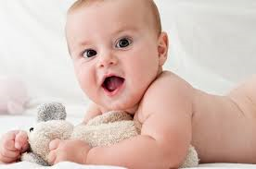
The human life cycle |  | toddler  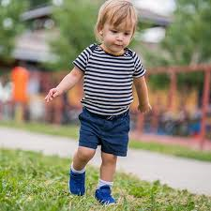
old age  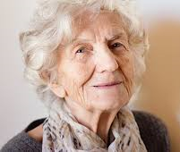 |  | child
adult  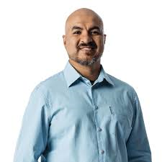 |  | teenager
Humans go through a variety of changes as we grow and develop from birth through to old age.

