PE Funding

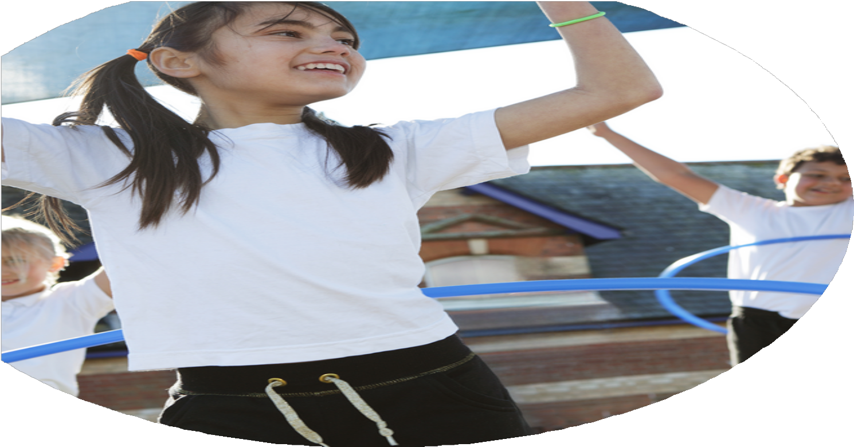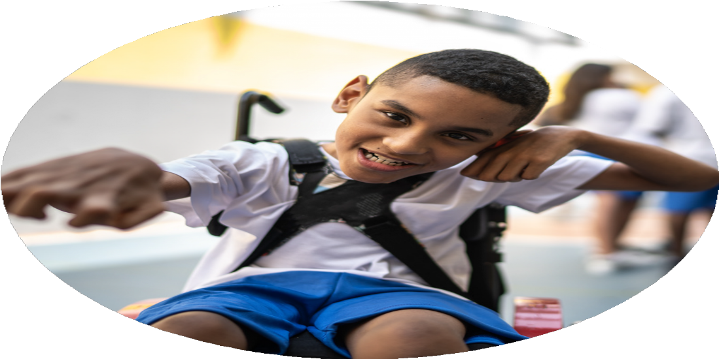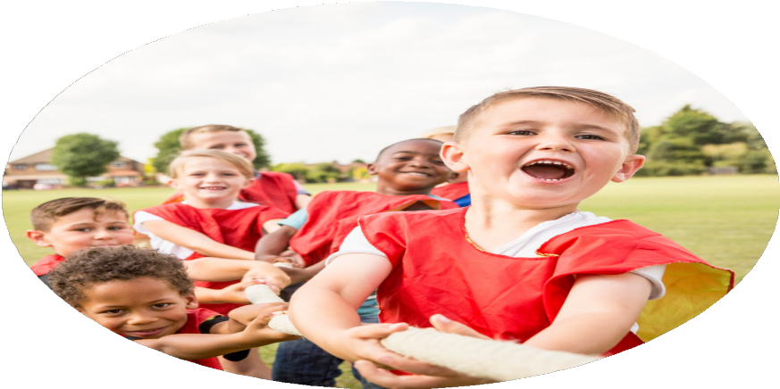

Evaluation Form

**Commissioned by**

**Created by**

Images courtesy of Youth Sport Trust

**PE Funding Evaluation Form**

 It is intended that this template should be used as preparation for the completion of the statutory digital reporting tool being introduced this academic year. You can upload data (including swimming) from this template onto this platform once it becomes accessible.

 Before you decide how you are going to use the funding for this academic year you should reflect and evaluate the impact of your use of the funding in 2023/24.

 All spending of the funding must conform with the terms outlined in the Conditions of Grant document.  The template is a working document that you can amend/update during the year.

 Based on your evaluation of last year’s funding you should decide what you intend to do this academic year, how you will do it, and what impact you expect it to have.

It is important that the funding is used effectively and based on your school’s needs.

 You must use the funding to make additional and sustainable improvements to the PE and sport in your school.  You must develop and add to the PESSPA activities that your school already offers.

*Summative digital reporting from June 2025 will continue to include swimming and water safety information therefore funding can be used to provide top-up lessons where necessary to ensure pupils meet national curriculum swimming requirements.*

Classes/children were not using the running track regularly throughout the year.

Developing a consistent use of the daily mile running track.

81% of children in KS2 attended an event/festival or competition through RSSP. Year 6 children took part in the transition events with our local high schools. We entered almost every SEND event possible through RSSP so that children had the opportunity to represent school by taking part in festivals and inclusions events. 100% of children on the SEND register and PP children were given the opportunity to represent school at an event. Children enjoyed representing their school and continue to look forward to representing Britannia in competitions and events in the future.

Children were active for longer periods of time through their sports day sessions. Children had the opportunity to access 9 different sporting activities in KS1, and 10 activities in KS2. Children, staff and parents were all extremely positive regarding the change and thoroughly enjoyed the day.

Over the year children were able to take part in workshops such as Kinball, Judo, Quidditch, Tag Rugby, Football. Children were encouraged to get in touch with local clubs and children joined local Judo, rugby and cricket clubs.

Staff were all trained on how to deliver OAA activities and use the orienteering infrastructure in the school grounds.

**To buy into RSSP and enter competitions/festivals/CPD/updates/transition events.**

**To develop sports day so that the activeness of children is vastly improved during the day.**

**To introduce new sports to the children and make local links with clubs.**

**OAA CPD**

What are your plans for 2024/25?

Intent

How are you going to action and achieve these plans?

Implementation

Liaise with the local SGO in-order to make full use of their package. Staff will have access to CPD in targeted areas. Children will have access to a competition schedule, inclusion events, playground leader training, festivals. We will continue to strive for GOLD and be recognized for our school commitment to PE.

All staff will be confident to assess / support and challenge during PE. Staff will be confident to assess and track individuals. This will ensure that lessons are appropriate and children who require support and challenge are identified.

Children will be more active at lunchtimes through adapting the playground rota for activities to ensure that all ages and genders have an opportunity to participate. Continue to train up sports leaders to deliver activities in KS1 and KS2 alongside FUNDA coach.

Purchase new equipment based on children’s interests and storage.

Through questionnaires and use of the PE App tracking our least active pupils and provide opportunities for children to take part in different activities. Provide some additional funded places at some clubs. Promote out of school opportunities and holiday clubs through the newsletters.

Develop an additional club run by a coach to target the least active pupils.

Children will take part in healthy cooking classes and learn what a healthy diet is made up of. They will take part in a change for life day during health week where they will think about their lifestyle and how it can be more active. Children will also take part in a healthy minds day in October 2024 so that they are aware of the role exercise can play in supporting their mental health.

Give girls in KS2 a platform to play football in a supportive environment.

Football, gymnastics, kinball, basketball, netball, dodgeball, cricket, rounders, kickboxing are offered. Plan specific sports days where local clubs visit to encourage uptake beyond school provision.

**To buy into the local SGO package to access CPD through Lancashire County Council and Youth Sports Trust**

**Staff to receive refresher training on use of PE Passport app, orienteering and Max Whitlock gymnastics scheme.**

**To continue to increase the amount of children being active outside the curriculum.eg. playtimes and lunchtime clubs.**

**Equipment bought for lunchtime activities KS1 and KS2**

**To encourage our least active pupils to take part in more physical activity through planned sports days, festivals and active learning.**

**To ensure that children have a positive attitude towards leading a healthy, active lifestyle. (Promote healthy eating – Healthy Eating Day with Fun Food Chef)**

**To continue developing girls football, train the team and enter girls football competitions.**

**To ensure there are a range of extra-curricular opportunities for all children**

Visit from Paralympian to deliver motivational workshops and wheelchair basketball in Sept. and June

To buy into RSSP and attend festivals / competitions / inclusion events / panathlons

Intra School Competitions, Glow Dodgeball, Football, Rounders or cricket, Athletics /cross country

Children will have opportunities to represent school in competitive environments which they may not get outside of school. This includes both boys and girls football leagues.

Continue to access transition events with Y6 e.g colour run, glow dodgeball.

Coach to support least active pupils for half a day per week- focus on PP and SEND. (Rotate with KS1, LKS2, UKS2)

Create a timetable for daily mile sessions for each year group. Liaise with PE Governor on ideas for fun runs throughout the year.

To develop a working relationship with Burnley FC to help develop sporting projects and opportunities in school

Arrange opportunities throughout the year for classes in KS2 to access cycling training.

**Children will develop resilient and motivated attitudes.**

**Children engage in a Paralympic sport.**

**Children will have the opportunity to compete for school**

**Develop intra school competitions so that children who do not get chance to compete at SGO competitions still have opportunities to experience a competitive sporting environment. This also includes children with SEND.**

**Join and compete in local school football and netball leagues**

**Prepare children for high school through school games transition events.**

**For children to develop their physical stamina. Pupils will also show more engagement within sports in school**

**To continue development of the daily mile and begin to develop links with the wider community through ‘fun’ runs**

**Make further links with Burnley football club**

**To continue to promote cycling through bikeability.**

Implementation

Intent

How are you going to action and achieve these plans?

What are your plans for 2024/25?

What impact/intended impact/sustainability are you

expecting?

How will you know? What **evidence** do you have or

expect to have?

Staff will go on training courses to develop their understanding. We will see the impact within their PE lessons and through Pupil and Teacher discussions.

We will attend multiple types of events throughout the year ranging from competitions, festivals, training opportunities and SEND specific events. Children will develop their enjoyment of sport and develop their physical fitness through engaging with the events.

We will see a variety of children being more active at lunchtimes through adapting the playground rota for activities to ensure that all ages and genders have an opportunity to participate. We will continue to train up sports leaders to deliver activities these activities in KS1 and KS2 alongside a coach.

With new equipment children will have a wider variety of activities to engage in.

Children will take part in healthy cooking classes and learn what a healthy diet is made up of. They will take part in a change for life day during health week where they will think about their lifestyle and how it can be more active. Children will also take part in a healthy minds day in October 2024 so that they are aware of the role exercise can play in supporting their mental health. Through pupil voice children should be able to relay key information about eating healthily and the benefits to having an active lifestyle.

Weekly girl’s football training sessions will take place. The girls will compete in a local school girl’s league and we will see more girls joining the training sessions.

Through pupil voice children will be able to discuss how to overcome problems and setbacks having listened to recounts from Shaun and Danny from their own sporting journey. Hopefully we will see more resilience and determination in our PE lessons and in SGO events.

Children will complete the daily mile consistently which will in-turn have a positive effect on their stamina. Family fun runs are to be planned throughout the year with hopes of engaging the community.

**Staff will have access to CPD in targeted areas and feel more confident at delivering specific areas of PE.**

**Children will have access to a competition schedule, inclusion events, playground leader training, and festivals.**

**To continue to increase the amount of children being active outside the curriculum.eg. playtimes and lunchtime clubs.**

**Equipment bought for lunchtime activities KS1 and KS2**

**To ensure that children have a positive attitude towards leading a healthy, active lifestyle. (Promote healthy eating – Healthy Eating Day with Fun Food Chef)**

**Girl’s football will continue to flourish through training sessions and entering girls football competitions. The number of girls playing football will continue to grow.**

**Children will develop resilient and motivated attitude through engaging in a Paralympic sport (Wheelchair basketball) and engaging in talks from two Athletes (Shaun Gash & Danny Butler)**

**To continue development of the daily mile and begin to develop links with the wider community through ‘fun’ runs**

What **impact/sustainability** have you seen?

What **evidence** do you have?

77% of KS2 have attended an event this year, and a small group of 10 children in KS1 have attended an event. We also have evidence from our SGO league table of all the events we have entered which include the likes of: Cross-country, basketball, dodgeball, indoor and outdoor athletics, football, golf, boccia and bowling. Some of these events have been targeting SEND child and have been run by Panathlon, an organization aspiring to give children with additional needs opportunities to engage in sport.

We have taken part in 4 boys football matches this year, along with 3 girls matches and a tournament.

Children are seen playing structured sports at break times and lunchtimes such as skipping, football, cricket, volley ball along with many other general play time games such as tag. Our coach helps to organize these, and chosen members of Year 5 and 6 help to facilitate the games.

In regards to the clubs, children in key stage 1 and lower key stage 2 have taken up half-termly clubs regularly. We discuss with children what clubs they would like to access and try and meet their desires where possible. Next year we will aim to engage upper key stage 2 in more exciting or new clubs to continue developing their engagement with sport afterschool.

Within the curriculum 90% of our children are considered to be working at expected or exceeding. Next year we will look to fully utilize the PE Passport assessment tool to help us identify those children who need further support within the PE curriculum.

Children talked positively of their Fun Food Chef sessions, and could identify what made the meals they cooked healthy. Some children even talked about going home and being inspired to recreate the meals they had made in school. Thinking about future years, we have discussed the idea of developing a child/parent cooking session for those children we identify as being less engaged with healthy eating so that we can develop the child and parent bond of creating a healthy meal together.

Girls engage in football training every Thursday, led by our coach. There has been between 12-15 girls attending most weeks, and with us now opening the group up to Years 3 and 4, the number has risen to 30. The girls in Years 5 and 6 have competed in 3 separate matches, whilst also competing in the SG tournament. Beyond this, we also made links with Burnley Football Club who sent out a coach to run a lunch time session in the summer term. The uptake of the session was much more than we had expected, so we will be looking to offer a girls lunchtime club next year either through Burnley FC, or through our own coach.

**As a school, throughout the year we have accessed competitions, inclusion events, and festivals.**

**We have seen a greater number of children engaging in organized sport at break times and lunch times. Afterschool clubs have also been very popular again, however, upper key stage 2 is an area for development after seeing a drop in numbers over the year.**

**Overall children’s sporting technique and stamina has developed for a large group of children over the year – this has been evident during competitions but also whilst in PE lessons.**

**Children have engaged in workshops such as Fun Food Chef which has developed their understanding of what makes a healthy diet, as well as the simplicity of making healthy food. Beyond this, we also had a local company ‘Healthy Minds’ in to deliver a Mental Health Day which included a variety of workshops – many of these workshops encouraged children to be active and developed the links between having a positive mental health and being active.**

**Girl’s football has continued to be popular through weekly training sessions and the girls have had multiple opportunities to compete in competitive matches. The number of girls in Years 5 and 6 has increased since last year, and during the summer term we have opened up the group to Years 3 and 4 to develop the uptake for future years.**

Children talked positively of the experiences and messages which Shaun and Danny encouraged the children to take away. Children could talk about the perceived challenges that people with disabilities have – whilst also appreciating that they are able to still compete and engage in physical activity. A child with a disability discussed about how he felt inspired to try more sports outside of school such as wheelchair basketball and football.

In the autumn term, Years 3, 4 and 5 accessed bikeability sessions. 24 out of 29 children in Year 5 completed their road cycling sessions.

Each class took part in the fun runs this year, and after having discussions with children, they are keen to participate in more next year. The general stamina of children had developed from the winter to spring run – and this was also apparent when taking children to the SG cross-country event in late spring. Next year, we will look to develop a parent and child event so that we can begin to engage the wider school community in keeping active.

Our coach frequently assessed the children on a week to week basis and evaluated the progress they had made from the first week to the last week of the half-term. Some children have accessed interventions for a full term, whereas others for just a half-term. Next year, we will be looking to develop a way to track and record this progress more closely so that we can more accurately gauge the progress made by certain pupils.

**Children have been inspired and motivated this year through the visits of Shaun Gash (Paralympic wheelchair basketballer) and Danny Butler (Champion Mountain Biker) – two athletes who have demonstrated resilience and determination throughout their sporting careers/lives. Children were engaged in their assemblies and took away positive messages from each. On both occasions of Shaun Gash’s visits, children in all classes were able to have a go at wheelchair basketball. This opportunity not only gave children an insight into the sport but also broke down barriers of disability – this was hugely important to us as we have a child with cerebral palsy in school who uses a walking frame and at times a wheel chair.**

**Children in Years 3, 4 and 5 engaged in cycling sessions to develop their cycling proficiency. Some children had never rode a bike before, so this was an important developmental opportunity for them. We will continue to offer KS2 bikeability sessions in future years to continue improving the cycling proficiency of our young people.**

**Children have engaged in fun runs this year using our daily mile track. In December the children were encouraged to complete the ‘Santa Run’ – which involved them dressing in festive attire and doing 6 laps of the track. We also ran a spring time event with the same intent. Children really enjoyed the events and this also developed their stamina. We do have considerations for future years to engage the wider community by inviting parents and carers to join in with the run. This will allow us to develop the whole school ethos of keeping physically active.**

**Throughout the year we have been identifying children who would benefit from PE interventions in regards to a range of factors, some of these include: least active, poor gross or fine motor skills, lacking in teamwork or communication skills. Through our coach’s interventions, the identified children have made good to very good progress in their specific areas.**

What evidence do you have?

What impact/sustainability have you seen?